**Automate the Web Application**

**Code:**

**Outputs:**

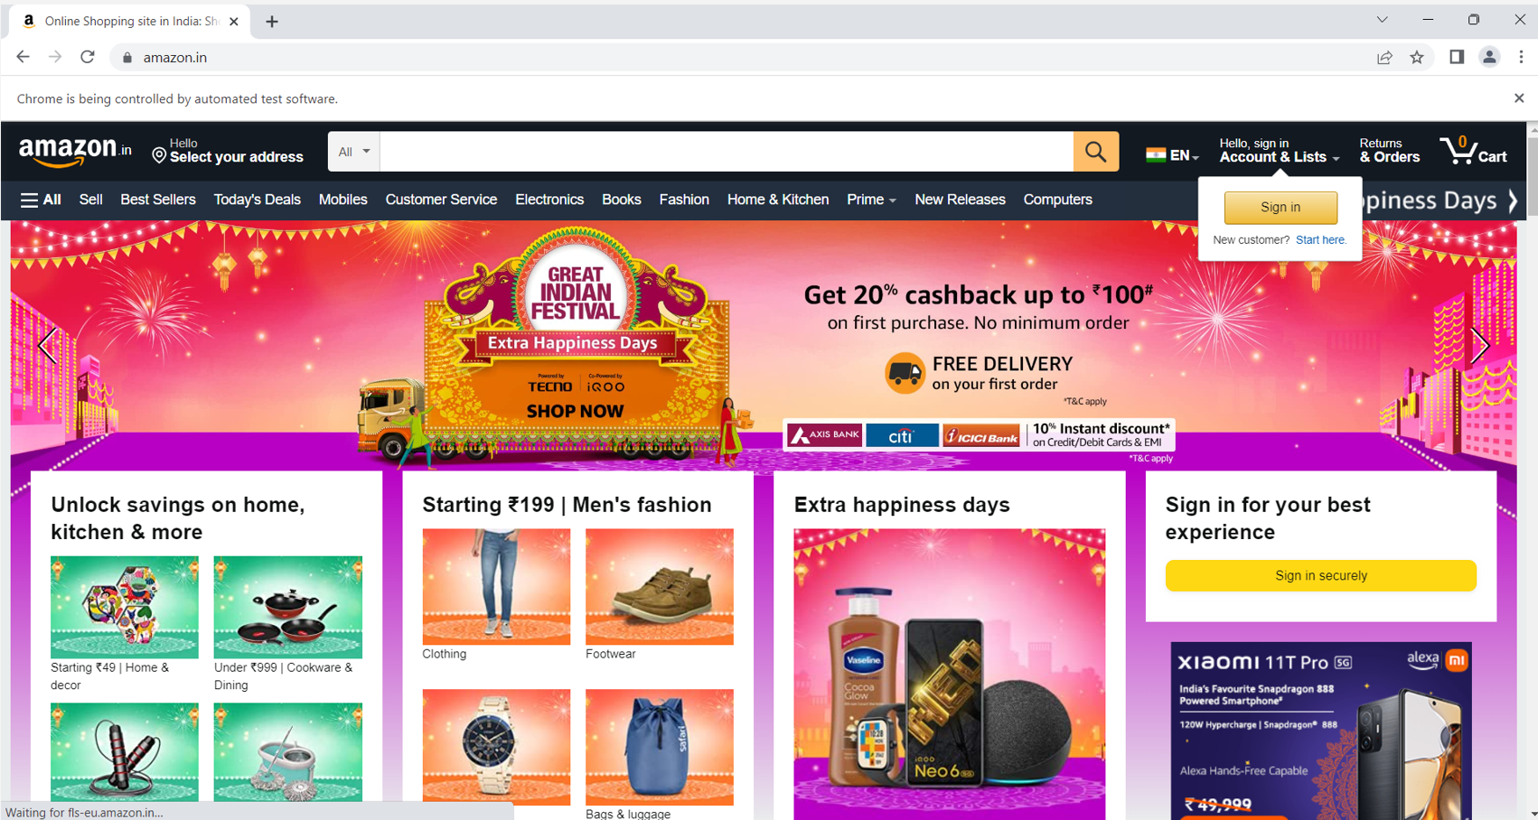

**In console:**



**In Console**

**TestNG report**

